HIS ADDRESS : | 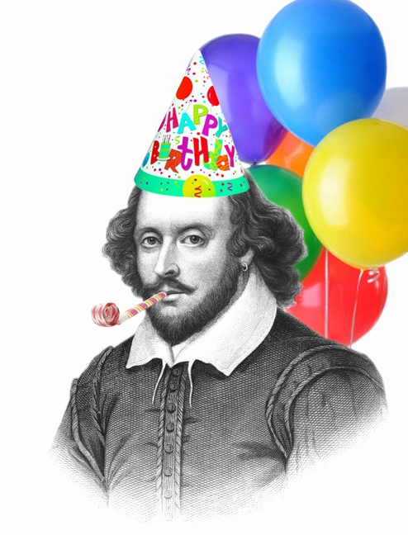

9 APRIL 2018 -

28 APRIL 2018

